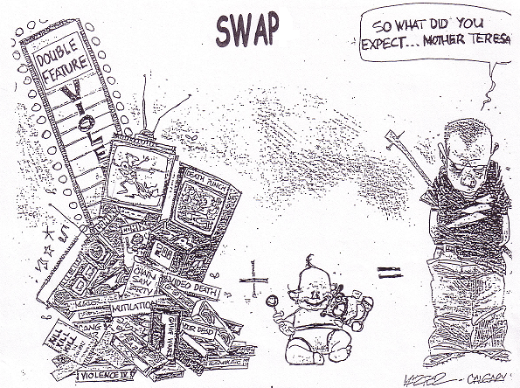

Symbols: Describe what you see drawn
Words: What do the words tell you?
Action: What action is taking place?
Point: What point is the cartoonist making?
Paragraph: Write a paragraph which analyzes the cartoon

